Lower Elementary:
Question: Laura and Harold are repotting orchids. They plant 2 orchid plants in each pot. When they’re done, they have 3 rows of 5 pots of orchids. How many orchid plants did Laura and Harold repot?

Upper Elementary:
Question: Christine has a cube-shaped box that is 1 foot wide that is completely filled with 1-inch cube-shaped blocks. She takes three-quarters of them out. How many blocks are left in the box?
Middle School:
Question: Noah ate ⁵/₁₂ of a bowl of ice cream. Brooklyn ate ⁶/₁₄ of the same ice cream. Who ate more ice cream? How much more?

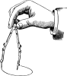
Algebra and Up:
Question: In the figure below, AG is a line and the measure of x is two times the measure of y. What is the value of y?
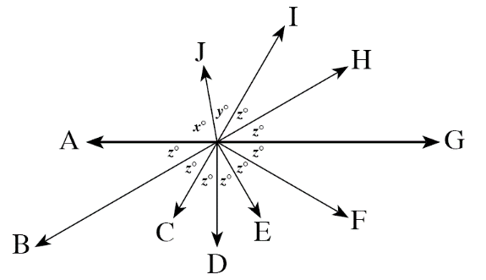

Lower Elementary:
Question: Laura and Harold are repotting orchids. They plant 2 orchid plants in each pot. When they’re done, they have 3 rows of 5 pots of orchids. How many orchid plants did Laura and Harold repot?
Answer: 30 orchid plants
Solution: Since there are 3 rows of 5 pots, there are 5 + 5 + 5 = 15 pots. Since there are two orchid plants in each pot, there are 15 + 15 = 30 orchid plants in total. Laura and Harold replanted 30 orchid plants.

Upper Elementary:
Question: Christine has a cube-shaped box that is 1 foot wide that is completely filled with 1-inch cube-shaped blocks. She takes three-quarters of them out. How many blocks are left in the box?
Answer: 432 blocks
Solution: A foot is 12 inches, so the box is 12 blocks wide × 12 blocks long × 12 blocks tall = 1,728 cube-shaped blocks in volume. If Christine takes three-quarters of the blocks out, that means that there’ll be one-quarter of them left in the box. So, we divide: 1,728 ÷ 4 = 432. There are 432 blocks left in the box.
Middle School:
Question: Noah ate ⁵/₁₂ of a bowl of ice cream. Brooklyn ate ⁶/₁₄ of the same ice cream. Who ate more ice cream? How much more?
Answer: Brooklyn ate ¹/₈₄ of the ice cream more than Noah.
Solution: To find the difference, we’ll need to find the least common denominator of the fractions. Since the LCM of 12 and 14 is 84, we need to convert the fractions to 84ths. Noah ate ⁵/₁₂ = ³⁵/₈₄ of the ice cream, and Brooklyn ate ⁶/₁₄ = ³⁶/₈₄ of the ice cream. Brooklyn therefore ate ³⁶/₈₄ – ³⁵/₈₄ = ¹/₈₄ of the ice cream more than Noah.

Algebra and Up:
Question: In the figure below, AG is a line and the measure of x is two times the measure of y. What is the value of y?
Answer: 40°
Solution: Since AG is a line, 6z = 180°. So, z = 180° ÷ 6 = 30°. We also know that x + y + 2z = 180°, or x + y + 60 = 180°, or x + y = 120°. If x = 2y, then we can conclude that 3y = 120°. So, y must be 120° ÷ 3 = 40°.

