Lower Elementary:
Question: Tori has reading homework that is 19 pages long. The homework is printed front-and-back on sheets of paper. How many sheets of paper are needed for the whole reading assignment?

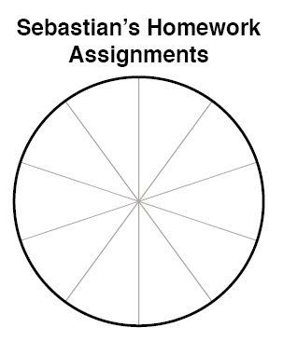
Upper Elementary:
Question: Sebastian completed 4 math assignments, 5 writing assignments, 7 reading assignments, 3 history assignments, and 1 science assignment last week. Fill in the pie chart to the right with Sebastian’s homework assignments.

Middle School:
Question: Lisa needs to memorize the locations of all 54 countries in Africa for a geography test that will be 30 days from now. She memorizes 7 countries every 3 days. Every 2 days, she forgets a country and needs to re-memorize it. Will she have enough time to memorize all of the countries in Africa for her geography test?

Algebra and Up:
Question: Logan has answered 0.8 times as many math questions as Spanish questions, and he’s answered 5 more English questions than Spanish questions. If Logan has answered 33 questions in total, how many math questions has Logan answered?

Lower Elementary:
Question: Tori has reading homework that is 19 pages long. The homework is printed front-and-back on sheets of paper. How many sheets of paper are needed for the whole reading assignment?
Answer: 10 sheets of paper
Solution: Since 2 pages can go on each sheet of paper, that means that the first 18 sheets of paper can fit on half of 18 = 9 sheets of paper. The 19th page goes on a 10th sheet of paper. So, 10 pieces of paper are needed for the whole reading assignment.

Upper Elementary:
Question: Sebastian completed 4 math assignments, 5 writing assignments, 7 reading assignments, 3 history assignments, and 1 science assignment last week. Fill in the pie chart to the right with Sebastian’s homework assignments.

Solution: Answers vary, but the math assignments should take up 2 segments on the pie chart, writing should take 2½, reading should take 3½, history should take 1½, and science should take ½.

Middle School:
Question: Lisa needs to memorize the locations of all 54 countries in Africa for a geography test that will be 30 days from now. She memorizes 7 countries every 3 days. Every 2 days, she forgets a country and needs to re-memorize it. Will she have enough time to memorize all of the countries in Africa for her geography test?
Answer: Yes
Solution: Since there are 10 3-day periods in 30 days, Lisa can memorize the location of a country a total of 7 × 10 = 70 times. That means she has time to forget and relearn 70 – 54 = 16 of them. If she forgets 1 every 2 days, that means she forgets 30 ÷ 2 = 15 of them, and since 15 is less than 16, she will have time to re-memorize them all.

Algebra and Up:
Question: Logan has answered 0.8 times as many math questions as Spanish questions, and he’s answered 5 more English questions than Spanish questions. If Logan has answered 33 questions in total, how many math questions has Logan answered?
Answer: 8 math questions
Solution: We can set up and solve the following system of equations to solve this problem:
M = 0.8S
E = S + 5
M + S + E = 33
Next, we plug the values of M and E into the third equation because they’re both already in terms of S. Now we have an equation with one variable—S. We can solve it to find that S = 10, so M must be 8. Logan has answered 8 math questions.

