Lower Elementary:
Question: Tyler has a sticker book that is 20 centimetres wide and 24 centimetres tall. He has a set of stickers that are each 5 centimetres wide and 8 centimetres tall. How many stickers will fit on a page of the sticker book?

Upper Elementary:
Question: Alli has a box that is exactly the right size to hold 7 layers of 9 rows of 11 cube-shaped erasers. How many erasers fit inside the box?

Middle School:
Question: Bobby is riding his tricycle around a quarter-kilometre track. If each wheel is 50 centimetres in diameter and turns 100 times, then how much further does Bobby need to pedal in order to complete a lap around the track?

Algebra and Up:
Question: The tessellating pattern below comprises regular pentagons and rhombuses. Find the measure of x.
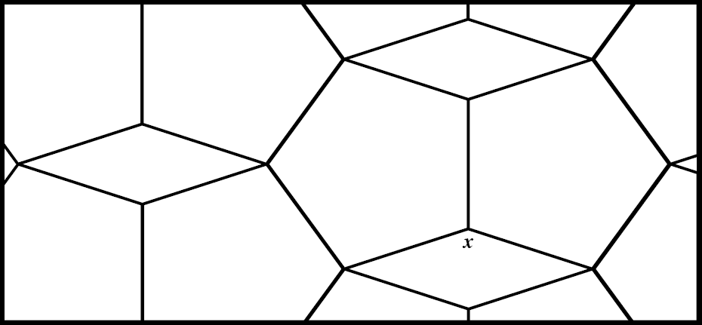

Lower Elementary:
Question: Tyler has a sticker book that is 20 centimetres wide and 24 centimetres tall. He has a set of stickers that are each 5 centimetres wide and 8 centimetres tall. How many stickers will fit on a page of the sticker book?
Answer: 12 stickers
Solution: Since each sticker is 5 centimetres wide and each page is 20 centimetres wide, that means Tyler can fit 20 ÷ 5 = 4 stickers in each row. Since the page is 24 centimetres tall and each sticker is 8 centimetres tall, that means Tyler can fit 24 ÷ 8 = 3 rows of stickers on each page. So, Tyler can fit 4, 8, 12 stickers on each page of his sticker book.

Upper Elementary:
Question: Alli has a box that is exactly the right size to hold 7 layers of 9 rows of 11 cube-shaped erasers. How many erasers fit inside the box?
Answer: 693 erasers
Solution: The length of the box is equal to 11 erasers, the width is equal to 9 erasers, and the depth is equal to 7 erasers. So, the box will hold 11 × 9 × 7 = 693 erasers in total.

Middle School:
Question: Bobby is riding his tricycle around a quarter-kilometre track. If each wheel is 50 centimetres in diameter and turns 100 times, then how much further does Bobby need to pedal in order to complete a lap around the track?
Answer: 93 metres
Solution: Each time the wheels rotate, Bobby moves forward 2πr ≈ 2 × 3.14 × ¼ metre = 1.57 metres. Since a kilometre is 1000 metres, the track is 1000 ÷ 4 = 250 metres. If Bobby turns his wheels 100 times, he will travel 157 metres, which means he will have 250 – 157 = 93 metres left to complete a lap around the track.

Algebra and Up:
Question: The tessellating pattern comprises regular pentagons and rhombuses. Find the measure of x.
Answer: 144°
Solution: Since the sum of the measures of all 5 vertices of a pentagon is 540°, that means that each angle is 540° ÷ 5 = 108°. Two 108° angles and x make a full 360° circle, so 360° – 108° × 2 = 360° – 216° = 144°. So, the measure of x is 144°.

