Lower Elementary:
Question: Tyler has a sticker book that is 8 inches wide and 9 inches tall. He has a set of stickers that are each 2 inches wide and 3 inches tall. How many stickers will fit on a page of the sticker book?

Upper Elementary:
Question: Alli has a box that is exactly the right size to hold 7 layers of 9 rows of 11 cube-shaped erasers. How many erasers fit inside the box?

Middle School:
Question: Bobby is riding his tricycle around a quarter-mile track. If each wheel is 12 inches in diameter and turns 100 times, then how much further does Bobby need to pedal in order to complete a lap around the track?

Algebra and Up:
Question: The tessellating pattern below comprises regular pentagons and rhombuses. Find the measure of x.
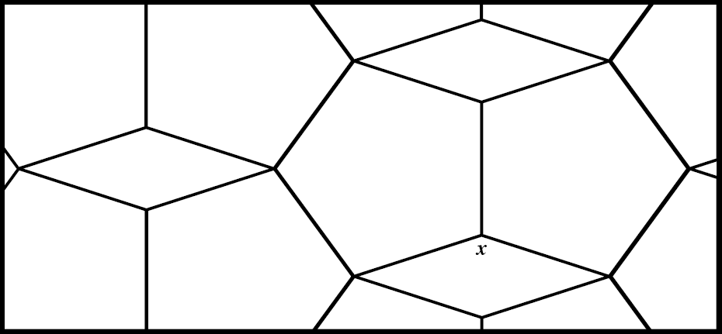

Lower Elementary:
Question: Tyler has a sticker book that is 8 inches wide and 9 inches tall. He has a set of stickers that are each 2 inches wide and 3 inches tall. How many stickers will fit on a page of the sticker book?
Answer: 12 stickers
Solution: Since each sticker is 2 inches wide and each page is 8 inches wide, that means Tyler can fit 8 ÷ 2 = 4 stickers in each row. Since the page is 9 inches tall and each sticker is 3 inches tall, that means Tyler can fit 9 ÷ 3 = 3 rows of stickers on each page. So, Tyler can fit 4, 8, 12 stickers on each page of his sticker book.

Upper Elementary:
Question: Alli has a box that is exactly the right size to hold 7 layers of 9 rows of 11 cube-shaped erasers. How many erasers fit inside the box?
Answer: 693 erasers
Solution: The length of the box is equal to 11 erasers, the width is equal to 9 erasers, and the depth is equal to 7 erasers. So, the box will hold 11 × 9 × 7 = 693 erasers in total.

Middle School:
Question: Bobby is riding his tricycle around a quarter-mile track. If each wheel is 12 inches in diameter and turns 100 times, then how much further does Bobby need to pedal in order to complete a lap around the track?
Answer: 1,006 feet
Solution: Each time the wheels rotate, Bobby moves forward 2πr ≈ ½ foot × 3.14 × 2 = 3.14 feet. Since a mile is 5,280 feet, the track is 5,280 ÷ 4 = 1,320 feet. If Bobby turns his wheels 100 times, he will travel 314 feet, which means he will have 1,320 – 314 = 1,006 feet left to complete a lap around the track.

Algebra and Up:
Question: The tessellating pattern comprises regular pentagons and rhombuses. Find the measure of x.
Answer: 144°
Solution: Since the sum of the measures of all 5 vertices of a pentagon is 540°, that means that each angle is 540° ÷ 5 = 108°. Two 108° angles and x make a full 360° circle, so 360° – 108° × 2 = 360° – 216° = 144°. So, the measure of x is 144°.

