Lower Elementary:
Question: A protocol droid and a utility droid are both trying to reach an escape pod so that they can get away from an evil imperial spacecraft. The protocol droid walks at a speed of 2 km/h. The utility droid rolls at a speed of 5 km/h. If they start from the same place, then which one will reach the escape pod first? How can you tell?

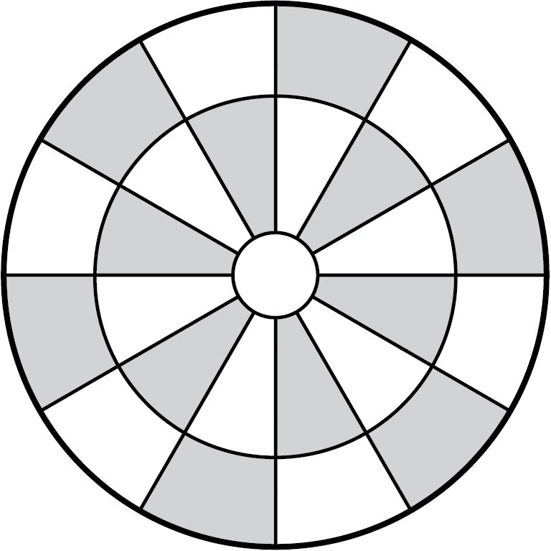Upper Elementary:
Question: Dejarik is a game played on a circular board. The game is for 2 players, and each player starts the game with 4 game pieces on the board. Each game piece takes up a single space on the board, which has 25 spaces in total. What percentage of the spaces are occupied if both players have all their game pieces in play?

Middle School:
Question: A smuggler’s starship navigates a shortcut through space to make the Kessel Run in 12 parsecs. The usual Kessel Run smuggling route is 18 parsecs. If a parsec is 3.26 light-years and a light-year is 9.46 trillion kilometres, then by how many trillions of miles does the smuggler shorten the Kessel Run? Round your answer to the nearest trillion miles.

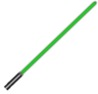Algebra and Up:
Question: A Space knight swings her laser sword in a full circle around her body. The laser sword’s energy blade is 3 metres in length. The Space knight holds the laser sword so that the blade emits from the hilt 4 metres from the center of the circle. Find the area in which the laser sword’s blade slices through the air.

Lower Elementary:
Question: A protocol droid and a utility droid are both trying to reach an escape pod so that they can get away from an evil imperial spacecraft. The protocol droid walks at a speed of 2 km/h. The utility droid rolls at a speed of 5 km/h. If they start from the same place, then which one will reach the escape pod first? How can you tell?
Answer: the utility droid
Solution: The faster droid will reach the escape pod first. Since 5 is more than 2, we can tell that 5 km/h is faster than 2 km/h. So, since the utility droid rolls at a speed of 5 km/h, it will reach the escape pod first.

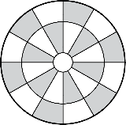
Upper Elementary:
Question: Dejarik is a game played on a circular board. The game is for 2 players, and each player starts the game with 4 game pieces on the board. Each game piece takes up a single space on the board, which has 25 spaces in total. What percentage of the spaces are occupied if both players have all their game pieces in play?
Answer: 32%
Solution: If each player has 4 pieces on the board, then there are 4 × 2 = 8 pieces on the board in total. Since there are 25 spaces on the board, ⁸/₂₅ of the spaces are occupied. We can turn the fraction into a percent by multiplying both the numerator and denominator by 4, since percentages are out of 100: ⁸/₂₅ × ⁴/₄ = ³²/₁₀₀ = 32%.

Middle School:
Question: A smuggler’s starship navigates a shortcut through space to make the Kessel Run in 12 parsecs. The usual Kessel Run smuggling route is 18 parsecs. If a parsec is 3.26 light-years and a light-year is 9.46 trillion kilometres, then by how many trillions of kilometres does the smuggler shorten the Kessel Run? Round your answer to the nearest trillion kilometres.
Answer: 115 trillion miles
Solution: Since the usual Kessel Run smuggling route is 18 parsecs and the smuggler’s starship makes it in 12 parsecs, the smuggler shortens the Kessel Run by 18 – 12 = 6 parsecs. Next, we convert 6 parsecs to trillions of kilometres by multiplying by the conversion rates: 6 parsecs × 3.26 light-years per parsec × 9.46 trillion kilometres per light year ≈ 185 trillion kilometres.

Algebra and Up:
Question: A Space knight swings her laser sword in a full circle around her body. The laser sword’s energy blade is 3 metres in length. The Space knight holds the laser sword so that the blade emits from the hilt 4 metres from the center of the circle. Find the area in which the laser sword’s blade slices through the air.
Answer: 33π square metres
Solution: To find the area in which the blade slices through the air, we find the area of a circle whose radius is 3 + 4 = 7 metres, then subtract the area of a circle whose radius is 4 metres for the space inside the circle where the laser sword’s blade doesn’t touch. The area of the full circle is πr² = π(7)² = 49π, and the area of the circle inside is π(4) ² = 16π, so the area inside is 49π – 16π = 33π square metres.

