Lower Elementary:
Question: An octopus lives in an underwater garden that is shaped like a rectangle. The fence around the garden is 7 metres on the long sides and 5 metres on the short sides. Draw a picture of the garden on graph paper. How many 1-metre squares are in the octopus’s garden, and how many metres of fence go around it?

Upper Elementary:
Question: John has a manuscript that is 1040 pages long. If it took him 2 years to write, then how many pages did John write per week on average?
(Hint: There are 52 weeks in a year.)

Middle School:
Question: A blackbird starts singing in the middle of the night, exactly between sunset and sunrise. If the sun sets at 5:37 pm and rises at 6:47 am, then at what time of night does the blackbird sing?

Algebra and Up:
Question: There is a hole in Paul’s ceiling where rain drips in at a rate of 15 millilitres per minute. As Paul fixes the hole, the rain that gets through decreases linearly. It takes him 2 minutes and 36 seconds to complete the task. How much rain gets in as Paul fixes the hole?
(Hint: Graph the decreasing rate of dripping rain in terms of time. What shape is formed under the graph?)

Lower Elementary:
Question: An octopus lives in an underwater garden that is shaped like a rectangle. The fence around the garden is 7 metres on the long sides and 5 metres on the short sides. Draw a picture of the garden on graph paper. How many 1-metre squares are in the octopus’s garden, and how many metres of fence go around it?
Answer: 35 square metres in area, 24 metres in perimeter
Solution: If we draw a picture of the garden broken into square metres, it’ll look like this:

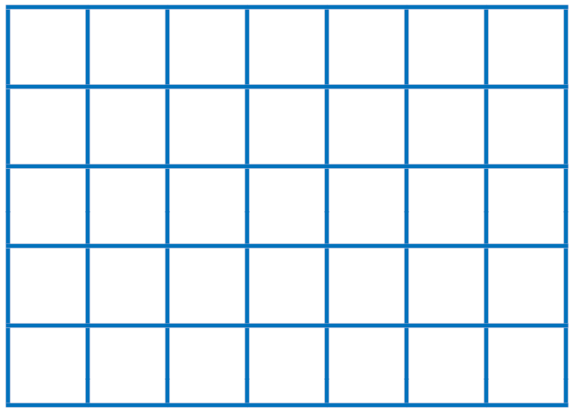

If we count the squares, we find that there are 35 square metres in the garden. If we count around, we see that the garden has 24 metres of fence around it.

Upper Elementary:
Question: John has a manuscript that is 1040 pages long. If it took him 2 years to write, then how many pages did John write per week on average?
(Hint: There are 52 weeks in a year.)
Answer: 10 pages per week
Solution: If there are 52 weeks in a year, then there are 104 weeks in 2 years. To find the average number of pages John wrote on an average week, we divide 1040 pages by 104 weeks and get 10. John wrote an average of 10 pages per week.

Middle School:
Question: A blackbird starts singing in the middle of the night, exactly between sunset and sunrise. If the sun sets at 5:37 pm and rises at 6:47 am, then at what time of night does the blackbird sing?
Answer: 12:12 am
Solution: First, we need to know how long the night is: there are 12 hours from 5:37 pm to 5:37 am and another 1 hour and 10 minutes until 6:47 am. So, the night is 13 hours and 10 minutes long. Halfway through the night is (13 hours + 10 minutes) ÷ 2 = 6 hours and 35 minutes after 5:37 pm, which is 12:12 am.

Algebra and Up:
Question: There is a hole in Paul’s ceiling where rain drips in at a rate of 15 millilitres per minute. As Paul fixes the hole, the rain that gets through decreases linearly. It takes him 2 minutes and 36 seconds to complete the task. How much rain gets in as Paul fixes the hole?
(Hint: Graph the decreasing rate of dripping rain in terms of time. What shape is formed under the graph?)
Answer: 19¹/₂ millilitres
Solution: When we graph the rate of dripping rain in terms of time, we get a line whose y-intercept is 15 millilitres per minute and whose x-intercept is 2³/₅ minutes. The shape formed under the graph is a triangle. To find how much rain gets in as Paul fixes the hole, we find the area of the triangle, which is ¹/₂ (15 millilitres per minute × 2³/₅ minutes) = 19¹/₂ millilitres.

