Lower Elementary:
Question: Jake plays his viola for at least 20 minutes each day. Each song he plays is 3 minutes long. What is the least amount of time Jake can spend playing the viola so that he finishes the song he’s playing at the 20-minute mark? How many songs does he play?

Upper Elementary:
Question: Finn is 15 decimetres tall and casts a 45-decimetre shadow. Jake is 7¹/₂ decimetres tall. If Jake stands on top of Finn’s head, how tall will their shadow be?

Middle School:
Question: Bonnibel is doing an experiment in her chemistry lab, but the labels on the ingredient containers of cinnamaldehyde, dextrose, glycerin, and sapodilla tree sap have peeled off. She knows that the cinnamaldehyde isn’t in either of the two largest containers, and the sapodilla tree sap isn’t in either of the two smallest containers. The ingredient in the second smallest container doesn’t have a smell, so it can’t be either dextrose or cinnamaldehyde. The last letter on the label of the second largest container hasn’t peeled off all the way, and it’s an “e.” Match the ingredients with their containers.

Algebra and Up:
Question: Simon has a magic crown that allows him to fly. He can fly 24 kilometres per hour when the weather is calm. If Simon flies straight from the top of a mountain that is ³/₄ of a kilometre tall to the ground 1 kilometre west of his initial location, then how long will it take him to reach the ground?

Lower Elementary:
Question: Jake plays his viola for at least 20 minutes each day. Each song he plays is 3 minutes long. What is the least amount of time Jake can spend playing the viola so that he finishes the song he’s playing at the 20-minute mark? How many songs does he play?
Answer: Jake plays 7 whole songs in 21 minutes.
Solution: To solve this problem, we can count by 3s until we pass 20: 3, 6, 9, 12, 15, 18, 21. So, the least amount of time Jake can spend playing the viola is 21 minutes. We counted 3, 7 times, so Jake plays 7 whole songs.

Upper Elementary:
Question: Finn is 15 decimetres tall and casts a 45-decimetre shadow. Jake is 7¹/₂ decimetres tall. If Jake stands on top of Finn’s head, how tall will their shadow be?
Answer: 22¹/₂ feet
Solution: Since Finn’s shadow is 45 decimetres, we know that the shadow is 45 ÷ 15 = 3 times his height. If Jake stands on his head, they are 15 + 7¹/₂ = 22¹/₂ decimetres tall altogether. So, their shadow will be 22¹/₂ × 3 = 67¹/₂ feet tall.
Middle School:
Question: Bonnibel is doing an experiment in her chemistry lab, but the labels on the ingredient containers of cinnamaldehyde, dextrose, glycerin, and sapodilla tree sap have peeled off. She knows that the cinnamaldehyde isn’t in either of the two largest containers, and the sapodilla tree sap isn’t in either of the two smallest containers. The ingredient in the second smallest container doesn’t have a smell, so it can’t be either dextrose or cinnamaldehyde. The last letter on the label of the second largest container hasn’t peeled off all the way, and it’s an “e.” Match the ingredients with their containers.
Answer: The cinnemaldehyde is in the smallest container, the glycerin is in the second smallest container, the dextrose is in the second largest container, and the sapodilla tree sap is in the largest container.
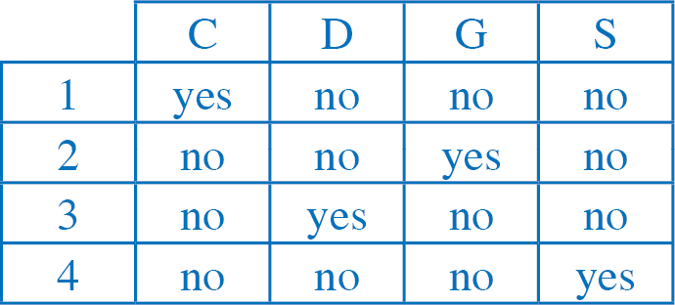
Solution: To solve this problem, we can set up a logic grid with the sizes of the containers ordered from smallest to largest and eliminate non-possibilities as we go.

Algebra and Up:
Question: Simon has a magic crown that allows him to fly. He can fly 24 kilometres per hour when the weather is calm. If Simon flies straight from the top of a mountain that is ³/₄ of a kilometre tall to the ground 1 kilometre west of his initial location, then how long will it take him to reach the ground?
Answer: 3¹/₈ minutes
Solution: To find the distance Simon flies, we find the length of the hypotenuse of a triangle whose legs are ³/₄ of a kilometre and 1 kilometre. Notice that if we call 1 kilometre “⁴/₄ of a kilometer,” we can see that this is a 3-4-5 triangle. So, the hypotenuse is ⁵/₄ of a kilometre. Simon flies 24 kilometres per hour, so we set up the equation ^{24 kilometres}/_{60 minutes} = ^{1¼ kilometres}/_{x minutes} and solve for x to find that it takes him 3¹/₈ minutes to fly to the ground.

